Jenkins Pipeline Setup

Step 1: Open Jenkins Dashboard and login with the respective Username and Password and click on Sign-In.

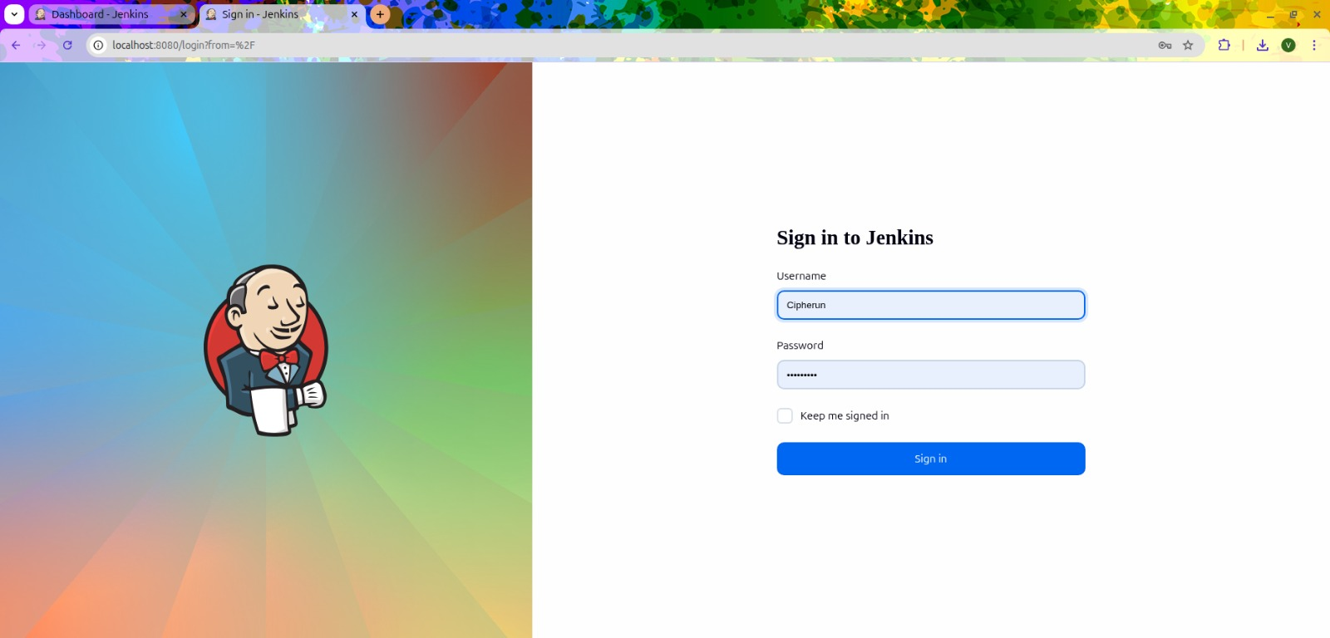

The Dashboard will be displayed like the below figure.

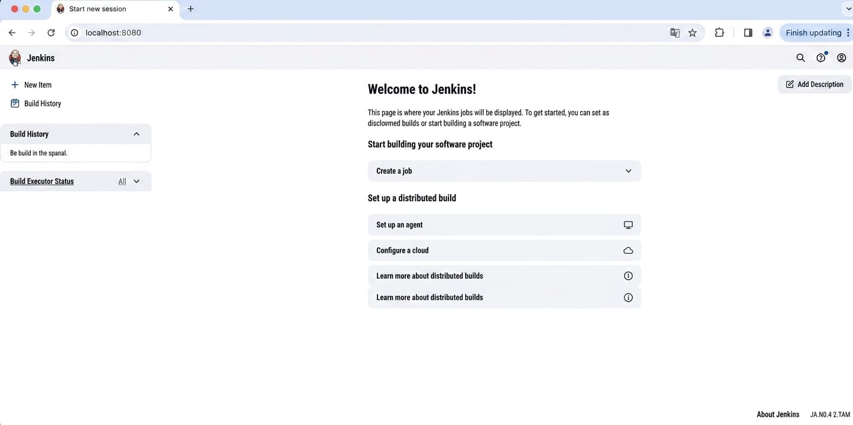

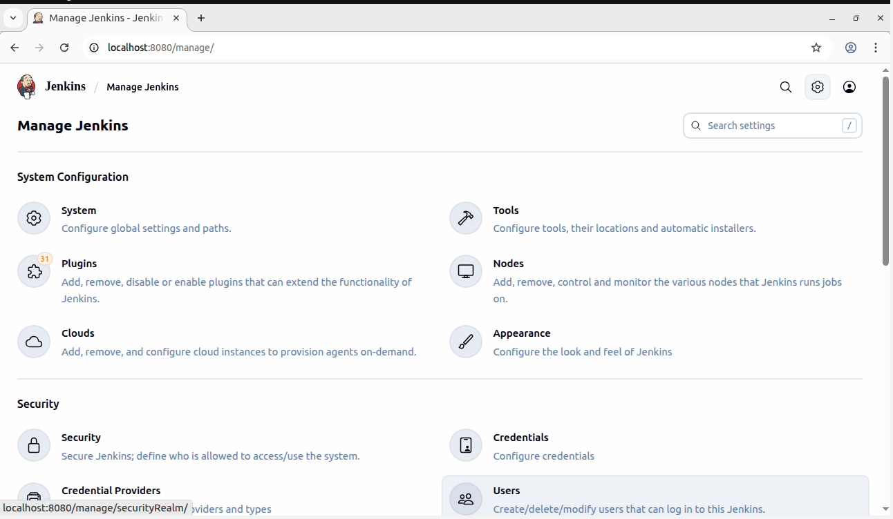
Step 2: From the dashboard, click on “Manage Jenkins” by selecting the settings icon located at the top right.

Step 3: Navigate to Plugins and download the required plugins i.e.

Maven Integration

GitHub Integration

Pipeline Stage View

Gradle
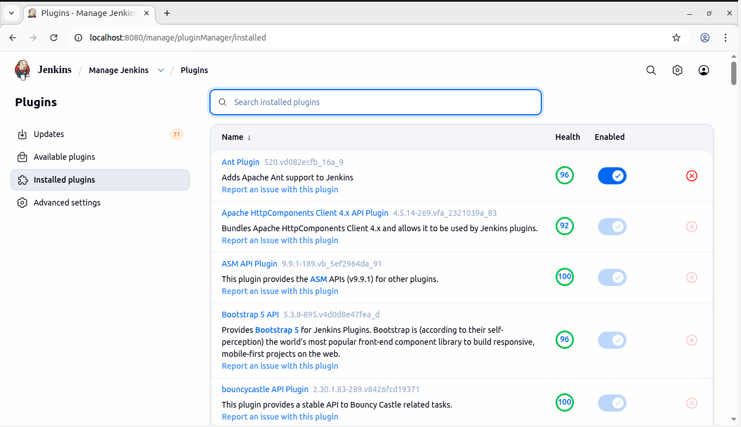

Step 4: We need to Verify Gradle Plugin as it would already be installed.
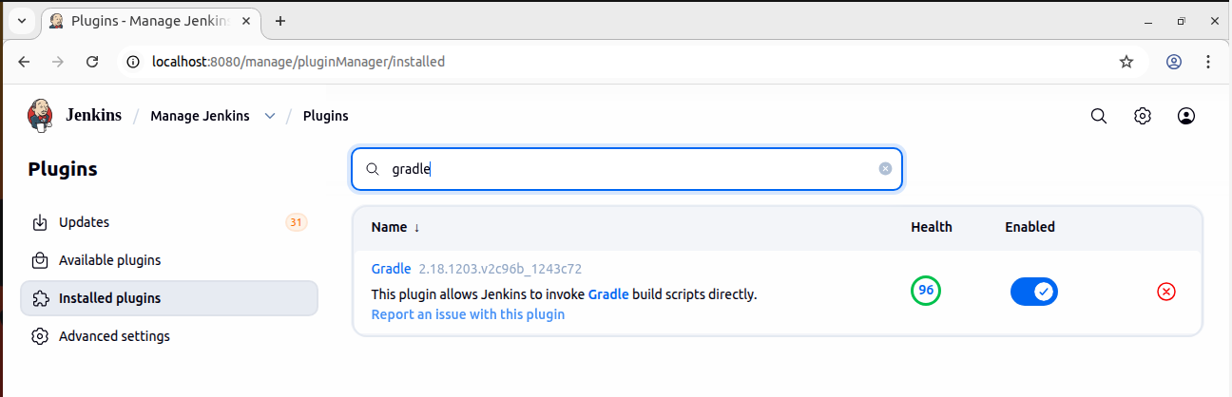

Step 5: Once the installation is complete restart Jenkins by visiting http://localhost:8080/safeRestart

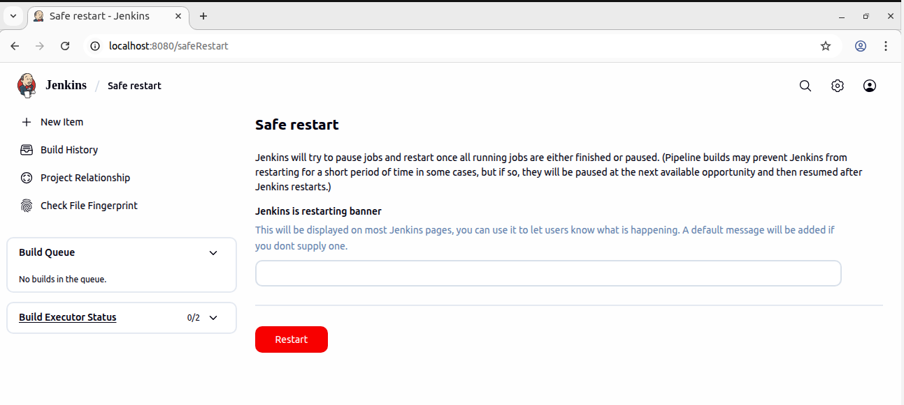

Step 6: We need to Configure Tools thus Go to Manage Jenkins → Tools.

Scroll down and click Add JDK.


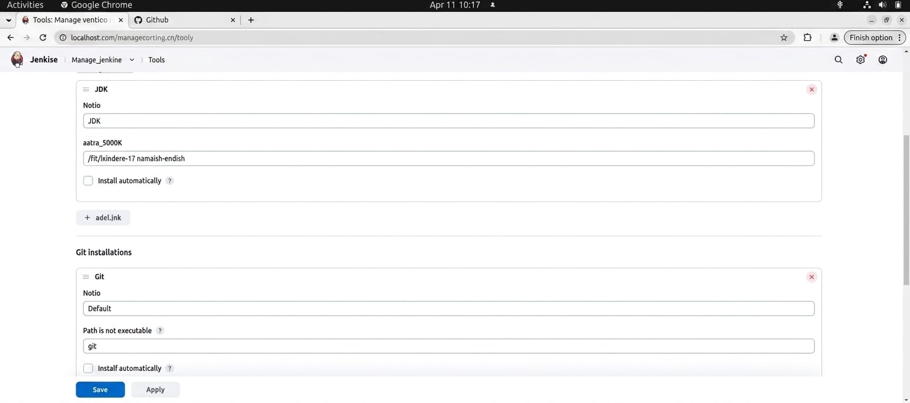

Enter the name and address
The address of the JDK can be found in your files -> other location -> computer -> lib -> jvm -> jdk

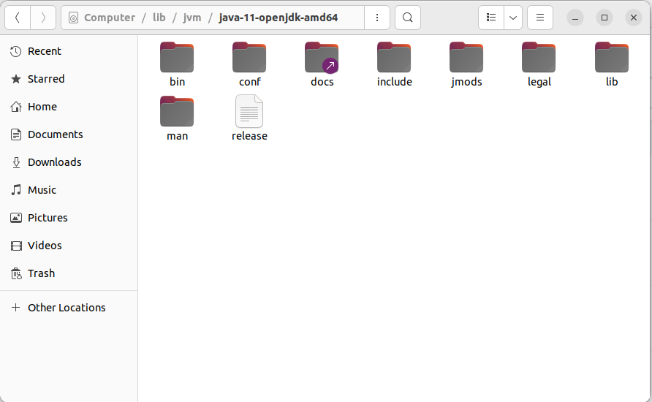

Step 7: Find installation paths for Git, Maven, and Gradle using terminal. Enter these paths in Jenkins.

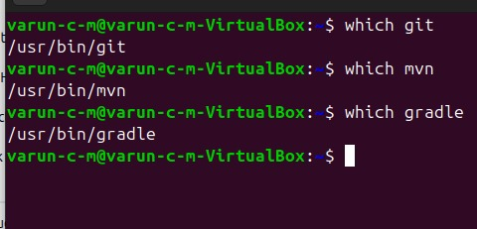

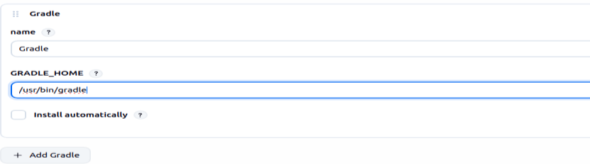
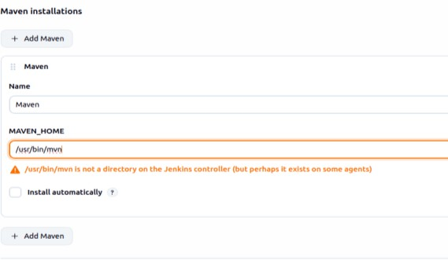
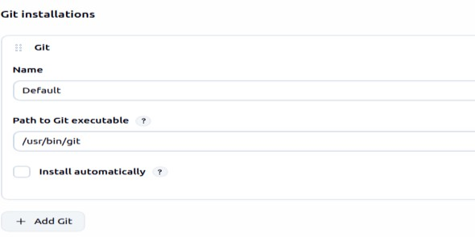

Step 8: To Add GitHub Credentials, we need to go to Manage Jenkins and click on Credentials. Here we need to select Username with Password. Here we give the GitHub Username and Password and description as “GitHub Credentials”

Here we Select Username with Password as the type of credential
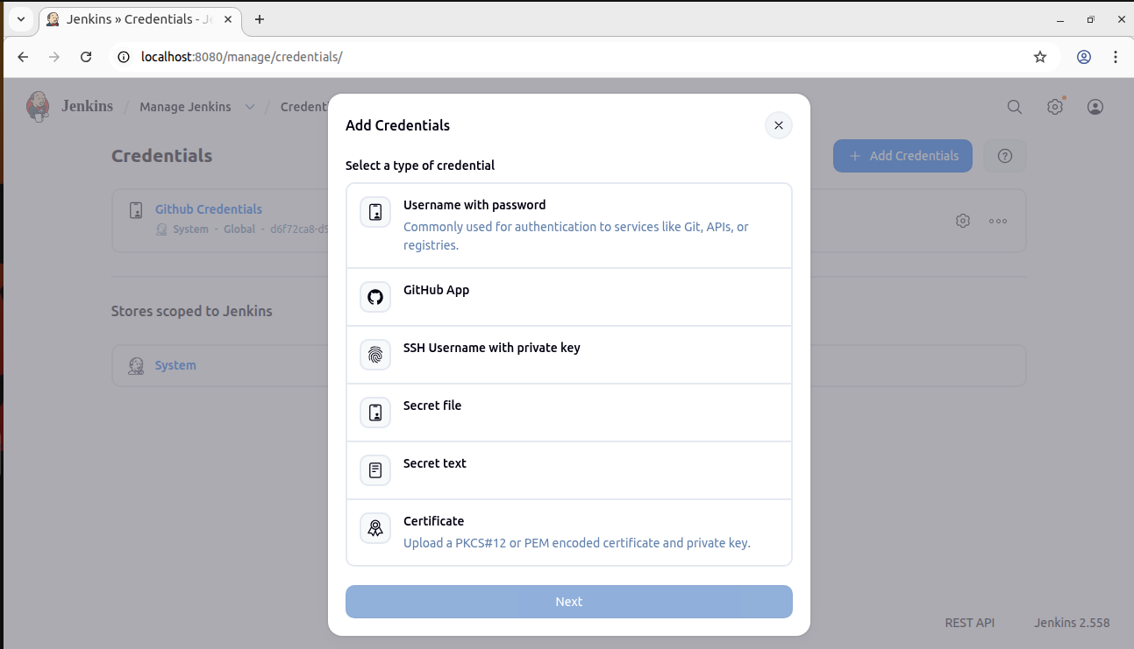

Here we give the Username and Password of GitHub and name it as GitHub Credential

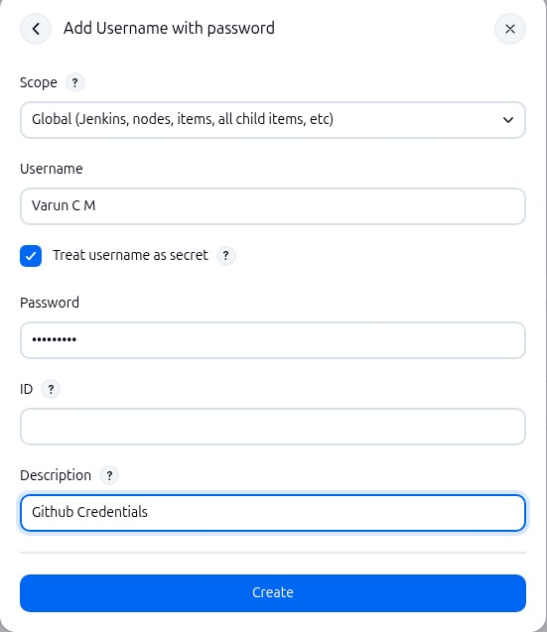

Thus ,the GitHub Credentials will be Successfully created as below

